**Practical 2**

**Familiarization with Networking Components and devices**

**1. HUB**

Networks using a Star topology require a central point for the devices to connect. Originally this device was called a concentrator since it consolidated the cable runs from all network devices. The basic form of concentrator is the hub.

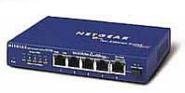  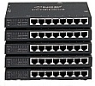

As shown in Figure; the hub is a hardware device that contains multiple, independent ports that match the cable type of the network. Most common hubs interconnect Category 3 or 5 twisted-pair cable with RJ-45 ends, although Coax BNC and Fiber Optic BNC hubs also exist. The hub is considered the least common denominator in device concentrators. Hubs offer an inexpensive option for transporting data between devices, but hubs don't offer any form of intelligence. Hubs can be active or passive.

An **active hub**strengthens and regenerates the incoming signals before sending the data on to its destination.

**Passive hubs**do nothing with the signal.

**Ethernet Hubs**

An Ethernet hub is also called a multiport repeater. A repeater is a device that amplifies a signal as it passes through it, to counteract the effects of attenuation. If, for example, you have a thin Ethernet network with a cable segment longer than the prescribed maximum of 185 meters, you can install a repeater at some point in the segment to strengthen the signals and increase the maximum segment length. This type of repeater only has two BNC connectors, and is rarely seen these days.

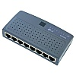   
 8 Port mini Ethernet Hub

The hubs used on UTP Ethernet networks are repeaters as well, but they can have many RJ45 ports instead of just two BNC connectors. When data enters the hub through any of its ports, the hub amplifies the signal and transmits it out through all of the other ports. This enables a star network to have a shared medium, even though each computer has its own separate cable. The hub relays every packet transmitted by any computer on the network to all of the other computers, and also amplifies the signals.

The maximum segment length for a UTP cable on an Ethernet network is 100 meters. A segment is defined as the distance between two communicating computers. However, because the hub also functions as a repeater, each of the cables connecting a computer to a hub port can be up to 100 meters long, allowing a segment length of up to 200 meters when one hub is inserted in the network.

**Multistation Access Unit**

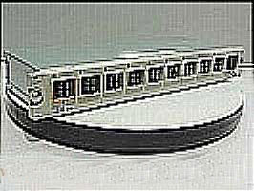

A **Multistation Access Unit (MAU)** is a special type of hub used for token ring networks. The word **"hub"** is used most often in relation to Ethernet networks, and MAU only refers to token ring networks. On the outside, the MAU looks like a hub. It connects to multiple network devices, each with a separate cable.

**Unlike a hub that uses a logical bus topology over a physical star, the MAU uses a logical ring topology over a physical star.**

When the MAU detects a problem with a connection, the ring will beacon. Because it uses a physical star topology, the MAU can easily detect which port the problem exists on and close the port, or "wrap" it. The MAU does actively regenerate signals as it transmits data around the ring.

**2. Switches**

On the surface, a switch looks much like a hub. Despite their similar appearance, switches are far more efficient than hubs and are far more desirable for today's networks enivornment.

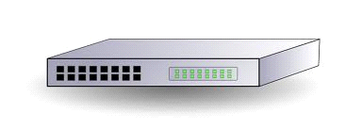

As with a hub, computers connect to a switch via a length of twisted-pair cable. Multiple switches are often interconnected to create larger networks. Despite their similarity in appear- ance and their identical physical connections to computers, switches offer significant opera- tional advantages over hubs. As discussed earlier in the chapter, a hub forwards data to all ports, regardless of whether the data is intended for the system connected to the port. This arrangement is inefficient however, it requires little intelligence on the part of the hub, which is why hubs are inexpensive. Rather than forwarding data to all the connected ports, a switch forwards data only to the port on which the destination system is connected.. You can see a representation of how a **SWITCH** works in **below figure** .

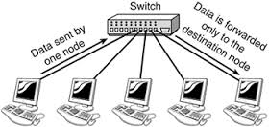

**3. LAN ADAPTER**

A LAN adapter is a device used to allow a computer to interface with a network. Many computers may have some sort of LAN adapter already installed, but others may require a special installation, which is accomplished by adding a network interface card to the system or possibly connecting the adapter to USB port.Most networks that are used in an office or home environment are known as local area networks (LANs). This type of network is one used over a limited geographic area. Most of the time, the network goes no further than the building which houses its main components, though that is not always the case. A LAN adapter is simply one that is able to access this type of network.

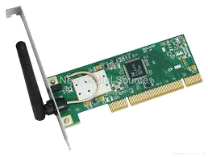

A LAN adapter can be used with a wireless or wired network.In many cases, a wired LAN adapter is used for ETHERNET connections, one of the fastest and most reliable forms of wired networks. Because of their performance and security, they are often used in office or business enviornments.

**Wireless USB LAN adapter:-** A high-speed wireless network card that is used to access a network through a USB port on a computer or laptop. Most wireless USB LAN adapters look like small USB flash drives and usually are based on the 802.11g standard which provides a data rate up to 54-Mbps in a wireless LAN environment. Some wireless USB LAN adapters may also support the 802.11b standard. A wireless USB LAN adapter basically enables you to share files, folders, printers, other network resources and Internet access.

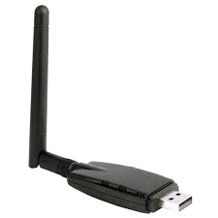

.

4. **BRIDGES**

A **Bridge** is used to join two network segments together, it allows computers on either segment to access resources on the other. They can also be used to divide large networks into smaller segments. Bridges have all the features of repeaters, but can have more nodes, and since the network is divided, there is fewer computers competing for resources on each segment thus improving network performance.

Bridges can also connect networks that run at different speeds, different topologies, or different protocols. But they cannot, join an Ethernet segment with a Token Ring segment because these use different networking standards.

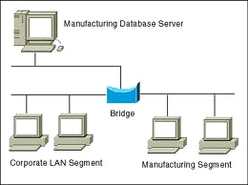

**5. ROUTER**

Routers Are networking devices used to extend or segment networks by forwarding packets from one logical network to another. Routers are most often used in large internetworks that use the TCP/IP protocol suite and for connecting TCP/IP hosts and local area networks (LANs) to the Internet using dedicated leased lines.Routers work at the network layer of the Open Systems Interconnection (OSI) reference model for networking to move packets between networks using their logical addresses (which, in the case of TCP/IP are the IP addresses of destination hosts on the network) Because routers operate at a higher OSI level than bridges do, they have better packet-routing and filtering capabilities and greater processing power which results in routers costing more than bridges.

Routers work at the network layer (layer 3) of the Open Systems Interconnection (OSI) reference model for networking to move packets between networks using their logical addresses (which, in the case of TCP/IP, are the IP addresses of destination hosts on the network). Because routers operate at a higher OSI level than bridges do, they have better packet-routing and filtering capabilities and greater processing power, which results in routers costing more than bridges.

**6. GATEWAYS**

A gateway is a device used to connect networks using different protocols. Gateways operate at the network layer of the OSI model. In order to communicate with a host on another network, an IP host must be configured with a route to the destination network. If a configuration route is not found, the host uses the gateway (default IP router) to transmit the traffic to the destination host. The default t gateway is where the IP sends packets that are destined for remote networks. If no default gateway is specified, communication is limited to the local network. Gateways receive data from a network using one type of protocol stack, removes that protocol stack and repackages it with the protocol stack that the other network can use.

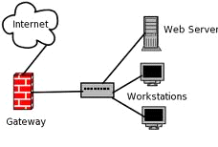

**7**. **MODEMS**

A modem is a device that makes it possible for computers to communicate over telephone lines. The word modem comes from Modulate and Demodulate. Because standard telephone lines use analog signals, and computers digital signals, a sending modem must modulate its digital signals into analog signals. The computers modem on the receiving end must then demodulate the analog signals into digital signals.

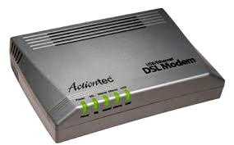

Modems can be external, connected to the computers serial port by an RS-232 cable or internal in one of the computers expansion slots. Modems connect to the phone line using standard telephone RJ-11 connectors.

**8. FIREWALLS**

In computing, a firewall is a piece of hardware and/or software which functions in a networked environment to prevent some communications forbidden by the security policy, analogous to the function of firewalls in building construction.

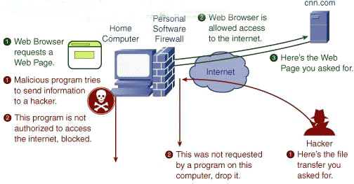

A firewall has the basic task of controlling traffic between different zones of trust. Typical zones of trust include the Internet (a zone with no trust) and an internal network (a zone with high trust). The ultimate goal is to provide controlled connectivity between zones of differing trust levels through the enforcement of a security policy and connectivity model based on the least privilege principle.

**There are three basic types of firewalls depending on:**

* whether the communication is being done between a single node and the network, or between two or more networks.
* whether the communication is intercepted at the network layer, or at the application layer.
* whether the communication state is being tracked at the firewall or not.